Topic 7: Data Collection, Sources, and Analysis
Once the problem is defined, we will know what data to collect. In this step we will decide what data to collect, the potential data sources, how to collect, and who will collect the data.
There are many categories of data in surveillance. They are identifying, demographic, clinical, laboratory, risk factor, and source (CDC, 2013)
- Explain with your own words each of the data categories! Provide an example for each of them.
- Identifying data : ………………………………………………………………..
- Demographic data : ………………………………………………………………..
- Clinical data : ………………………………………………………………..
- Laboratory data : ………………………………………………………………..
- Risk factor data : ………………………………………………………………..
- Source data : ………………………………………………………………..
- Data collection is started by deciding what data to collect based on the previous step (problem definition).
- If you are going to do an integrated surveillance of injury and disease in a village with most of the societies are tobacco farmers, what are the potential data for this problem? Find as many as possible!
…………………………………………………………………………………………………………………………………………………………………………………………………………………………………………………………………………………………………………………………………………………………………………
- Data of integrated surveillance can be collected from workers as the host, hazards and risks as the agents, and workplace as the environment. The following table is an example of possible data and the sources of integrated surveillance.
Host (workers) | Agents | Workplace (environment)
- Education  - Training experience  - Lifestyle  - Work capacity  - Knowledge  - Sex  - Medical record  - Age  - Skill  - Experience  - Etc | - Possible hazards and risks  - Time of exposure  - Size of exposure  - Duration of exposure  - Variation of exposure  - Etc | Work culture:  - Work norms  - Safety behaviour  - Safety climate  - Etc  Management:  - Workload  - Management commitment  - Decisions  - Funding  - SOP  - Etc

- Based on the example above, make your own table of possible data and the sources of an integrated surveillance of injury and disease in a village with most of the societies are tobacco farmers. You can also make the list of injuries and diseases that possibly occur.
Host (workers) | Agents | Workplace (environment)

- Another thing to do in data collection is developing instruments to collect the data. Data collection can be done through interview, questionnaire, etc.
- Find an example of data collection instrument of surveillance (injury, disease, etc). Make your own judgment about the instrument (the strength and weaknesses).
…………………………………………………………………………………………………………………………………………………………………………………………………………………………………………………………………………………………………………………………………………………………………………
- The next step to do is data analysis. Data processing systems can be either manual or electronic (WHO, 2001). But with the development of technology electronic data processing is likely preferred. Some free data processing software such as Epi info can be freely downloaded to help data analysis. We are not going to discuss about the analysis with software. We are going to discuss how data analyzed through descriptive and risk factor analysis.
- Descriptive
Descriptive analysis is performed by describing the distribution of a health condition or event in a community (person, place, time) (CDC, 2013). In descriptive analysis, data analysis begins with characterizing the pattern of disease/injury reports by some indicators (person, place, time) (Roush, S.W., 2011).
In descriptive analysis, data are analyzed by finding the frequency of each group of an indicator then interpret the data to decide the right preventions.
- Here is an example of data frequency by place
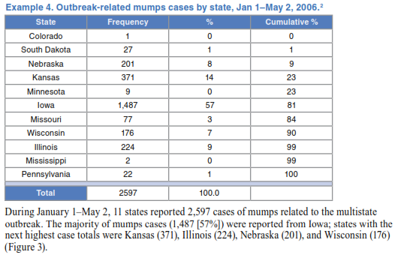
(Roush, S.W., 2011)
Based on the table, make your own interpretation about the data and think of possible recommendation or interventions!
………………………………………………………………………………………………………………………………………………………………………………………………………………………………………………………………………………………………………………………………………………………………………....
- Risk factors
This analysis is performed by identifying the potential factors of a health condition or event. There are two types of risk factors: modifiable and non-modifiable. (CDC, 2013)
- Put the following indicators into modifiable or non-modifiable group.
(Age, lifestyle, sex, race, heredity, smoking habit)
Modifiable : ……………………………………………………………….
Non- modifiable : ……………………………………………………………….
- Write four other examples of modifiable behaviour risk factors.
………………………………………………………………………………………………………………………………………………………………………………………………………………………………………………………………………………
- Find an example of surveillance data based on risk factor analysis. Make your own interpretation about the data.
……………………………………………………………………………………………………………………………………………………………………………………

